[Business Plan Title]
[Business Plan Subtitle]
Note: This template is nine pages and we thought it was too long. If your business plan is longer than nine pages, we probably won’t read it.
If you can cover these topics well with less pages (and no tricky formatting here, please), we’ll be impressed. Extra points for brevity!
Pro Tip: charts and graphs speak volumes without the need for words.

Executive Summary
This is the executive summary for your business plan, a short paragraph that explains what you do, why the market needs it, and how you intend to provide it.

Financial Highlights
Use the chart below to include financial highlights to include in the executive summary. If you have no revenue yet, then give us a forecast. This is just a chart.
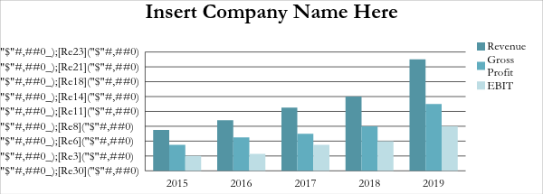

Company Description
This is additional description of what your company does, why the market needs it, and how you intend to provide it. Use this space to provide a brief overview of the subsections below. Remember: brevity is best.

Company Ownership/Legal Entity
Indicate the type of your business. For example, is it a sole proprietorship, LLC, C corporation, partnership, or other type of entity? Define the business type (such as manufacturing, merchandizing, or service), a brief mention of the products/services you provide and provide information regarding what licenses or permits are required (if necessary). If you do not have the required licenses or permits, describe the requirements for acquiring them and where you are in the process.

Location
Where will the business be located? A physical location? Online? And why that location?

Management
Provide brief, relevant details on the key managers including professional experience, educational qualifications and track record in business (if applicable in another start-up or successful growth business). Focus on providing information relevant to the success of your business, and avoid unnecessary details that do not support the business or provide confidence in the management team.

Service and Product Summary
Provide a description of your service and products in this section. Use this first section to summarize your offerings.

Current Unmet Need
Use this section to explain the current unmet need in the market that you intend to provide. Use your own data if possible. Show how your products/services will provide this unmet need.

Differentiation
Use this section to show how your company, as well as its products/services, will differentiate themselves from competitors and substitutes. What makes you different from the competition? Why do those differences matter to the customer?

Suppliers
Who are the primary suppliers for your company? Do you already have a bill of materials and cost estimates from them? How well do you understand the cost of your business?

Service and Support
Whether or not your company provides products or services, you will need to provide order fulfillment and customer service to your customers. How do you intend to do this? What is your plan to improve this as the company grows?

Manufacturing/Service Processes
Do you manufacture? If so, what facilities, special machinery, equipment, or manufacturing processes do you have?
How will you handle shipping and logistics? Is there a significant remaining capital investment you need for facilities, equipment or training? Why is this needed, when is it required, and how much will it cost?
If you are providing services, what skills and processes do your employees need to do their jobs?

Market Analysis
The first part of this section should cover market size and scope. Define the geographic or customer limits to your addressable market. Use the graph below to show the defined market size and year over year growth of your market by segments. We love pictures, they tell the story where words fail, so more charts and less words, please.
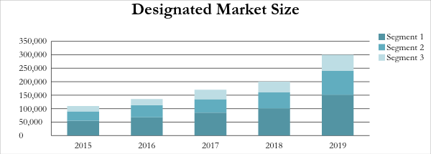
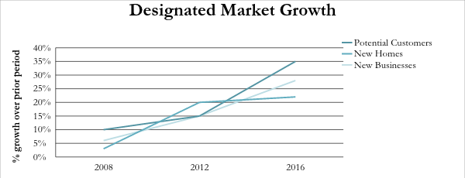

Customer Definition
Who is the target customer for your business? Where do they buy? How do they prefer to buy? What do they buy? What characteristics of the customer are unique and relevant to your business?

Market Segmentation
How is your target market segmented? Are there different types of consumers who have different product/service requirements and unmet needs? Are there different types of product/service providers within the same type of business, each offering a difference in quality, price, or range of products?
Is this market segmentation governed by geographic area, product lines, pricing, or other criteria?
Into which market segment will your primary business fall? What percentage of the total market is this segment? What percentage of this segment will your business reach?
Make sure that the segments you use in this chart match the segments used in the total market size chart above.
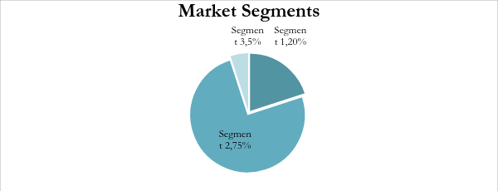

Five Forces Model
Provide a SWOT summary of the market based upon the five forces model in this section. Use the headings below to provide the detail for each of the five forces
Strengths  Based upon your five forces analysis, what are the company’s competitive strengths. | Weaknesses  Based upon your five forces analysis, what are the key weaknesses and potentially faulty assumptions of your competitive position?
Opportunity  Based upon your five forces analysis, what opportunities exist in the market that are related to your unmet needs assessment? | Threats  Based upon your five forces analysis, what are the key external threats to the business?

Suppliers
Include a detailed assessment of the relative, strategic strength of suppliers to your business. Who are they? What pricing power do they have? What are their competitive strengths and how do they compete for business?

Substitutes
Include a detailed assessment of the threat of substitutes to your business. What substitutes exist? How competitive are they given your unmet needs assessment?

Rivals
What companies will compete against you? This is not a substitute product, but something that will compete directly with you offering similar products/services. How do companies compete in this space? Is competition defined by price? Or, are the leading companies successful for reasons other than price alone?

Barriers to Competition
What prevents someone from entering this market? Are there legal or cost restrictions that would prevent them from entering your line of business? Explain your reasoning in detail, because no barrier is insurmountable.

Customers
How do customers make their purchase decision? Do they have pricing power over you? How do they perceive the industry and how does that affect your ability to be profitable?

Marketing and Sales
Use this space to summarize the structure of your sales team and how you will support them with a marketing/lead generation plan.

Marketing Plan
How will customers become aware of your company/product/service? How do you know this will work? Does this marketing plan make sense given the unmet need and customer profile? Why?
What is your marketing budget? How do you intend to spend this money? What assumptions do you have about your marketing expenditure?

Pricing
How did you develop your pricing model? What cost assumptions are implicit in your model? Compare your pricing to substitutes or rivals in the market. How does it compare and why? What value are you offering

Channel Strategy / Go to Market
How do you intend to sell your product? Will you have a sales force working with customers? Do you rely upon distributors? Are you selling wholesale or retail? Describe the path to the customer, and show the estimated pricing mark-ups for each reseller (if applicable).

Sales Process
How will you get a lead from marketing, follow up with a sales contact, detail the required number of sales contacts for each customer and why each is necessary (do this only if your sales process is a multi-part sales pitch), close the sale, and deliver the product. Show the estimated time to complete each task. Again, charts and timelines are better than words.
Include information about your sales team structure, incentive pay and other relevant items if you have person-to-person sales. If you are using online only sales, you will need to detail your online marketing plan including assumptions around eyeballs, click through rates, cost per click, cost per lead, conversion rates, conversion costs, and overall assumptions related to your online sales process.

Funding Plan
Summarize the total cash needs of your business in this space including how much money is already invested, who made those investments, how much money is still required, and how that money will be spent. Include a valuation, debt table, and asset table for the company if you are seeking external financing.

Start-Up Expenses
This section details the money you and the other founders have already spent to get the business started. It is only provided as an example. You should customize the expenses to suit your business.
Business Licenses
Incorporation Expenses
Deposits
Bank Account
Rent
Interior Modifications
Equipment/Machinery Required:
Item 1
Item 2
Item 3
Total Equipment/Machinery
Insurance
Stationery/Business Cards
Brochures
Pre-Opening Advertising
Opening Inventory
Other (list):
Item 1
Item 2
Startup exspenses | total here

Use of Funds
What will you do with the $100,000 we invest with your company?

Financial and Operating Projections
Summarize and list the financial/operating data included in this section using this space. Feel free to list or use a table to show what information is in this section.
A five year forecast is the norm, but you can do what works best for your company. We like GAAP, and again, charts and tables are better than words.

